AGILE SPRINT PLANNING & USER STORY WORKSHOP
AI-Powered Smart Disaster Relief Resource Allocation and Coordination Platform
A Sprint 1 Planning Document Applying Agile Software Engineering Practices
Field | Details
Submitted By | K.Sujith Sai Vighnesh
Register No. | 192311199
Department | CSE
Subject | Software Engineering
Faculty | Dr. Latha R.
College | SIMATS Engineering
Academic Year | 2023 – 2027

1. Project Vision and Stakeholders

1.1 Project Vision
To design and deliver a cloud-based, AI-driven disaster relief coordination platform that gives government agencies, NGOs, and emergency responders real-time visibility into relief resources and affected communities. The platform will use AI to forecast resource demand, GIS and IoT data to assess disaster severity, and optimization algorithms to plan efficient distribution logistics — enabling faster, better-coordinated relief operations that reduce human suffering and strengthen community resilience.

1.2 Project Objectives
- Provide real-time monitoring of relief resources (food, medicine, shelter supplies, rescue equipment).
- Use AI models to predict resource demand based on disaster severity, population, and historical data.
- Optimize relief distribution routes using GIS and live road/traffic conditions.
- Enable coordinated communication and task allocation across multiple relief agencies.
- Track shelter occupancy in real time to guide displaced citizens to available capacity.
- Generate automated emergency logistics and performance reports for decision-makers.
- Improve overall disaster response efficiency and reduce distribution delays.

1.3 Key Stakeholders
Stakeholder | Role / Interest in the Platform
Government Disaster Management Authority | Oversees overall response, approves resource release, sets zone priorities, and consumes reports.
NGOs / Relief Organizations | Supply and distribute food, medicine, and shelter materials; coordinate with other agencies via shared dashboard.
Emergency Responders / Rescue Teams | Carry out rescue and first-aid operations; need severity maps and real-time task assignment.
Shelter Managers / Camp Administrators | Manage shelter capacity and update occupancy status.
Logistics & Transport Providers | Move relief supplies; need optimized routes and vehicle tracking.
Affected Communities / Citizens | End beneficiaries; need visibility into nearby shelters and aid availability.
Volunteers | Support field operations and data collection through the mobile app.
IoT / Sensor Network Operators | Maintain sensors (weather, water level, structural) feeding severity assessment.
Platform Administrators / IT Team | Maintain system uptime, data security, and integrations.
Donor Agencies | Fund operations; require transparency reports on resource utilization.

2. Epics and User Stories
The product requirements have been organized into seven Epics. Each Epic is decomposed into User Stories following the format: "As a <user>, I want <feature>, so that <benefit>."

Epic 1 — Real-Time Resource Monitoring & Inventory Management
- US1: As a warehouse manager, I want to track relief supply inventory levels in real time, so that I always know what resources are available.
- US2: As a relief coordinator, I want to receive automatic low-stock alerts, so that I can reorder critical supplies before they run out.
- US3: As a field responder, I want to update resource usage from a mobile app, so that inventory records stay accurate at all times.

Epic 2 — AI-Based Demand Prediction
- US4: As a relief coordinator, I want the system to predict resource needs using disaster severity and population data, so that I can allocate supplies proactively rather than reactively.
- US5: As a government official, I want AI-generated demand forecasts broken down by region, so that I can prioritize aid distribution to the worst-affected areas.

Epic 3 — Optimized Relief Distribution & Logistics Routing
- US6: As a logistics manager, I want the system to calculate optimal delivery routes accounting for road damage and traffic, so that relief supplies reach affected areas faster.
- US7: As a delivery driver, I want turn-by-turn navigation that updates in real time, so that I can avoid blocked or unsafe routes.
- US8: As a relief coordinator, I want to track delivery vehicles on a live map, so that I can monitor progress and reroute shipments if needed.

Epic 4 — Multi-Agency Coordination & Communication
- US9: As an NGO coordinator, I want a shared dashboard visible to all participating agencies, so that we avoid duplicate efforts and resource conflicts.
- US10: As an emergency responder, I want to send and receive real-time alerts with other agencies, so that rescue operations are coordinated effectively.
- US11: As a government official, I want to assign specific zones and tasks to different agencies, so that responsibilities are clear and non-overlapping.

Epic 5 — Shelter Occupancy Management
- US12: As a shelter manager, I want to log and update shelter occupancy in real time, so that displaced people can be directed to shelters with available space.
- US13: As a displaced citizen, I want to view nearby shelters with available capacity on a map, so that I can find safe accommodation quickly.

Epic 6 — Emergency Reporting & Analytics Dashboard
- US14: As a government official, I want automated logistics and relief-status reports, so that I can review response performance and report to higher authorities.
- US15: As a relief agency director, I want visual dashboards of resource distribution and coverage gaps, so that I can make informed strategic decisions.

Epic 7 — Disaster Severity Assessment (GIS/IoT-based)
- US16: As a disaster analyst, I want the system to assess disaster severity using satellite/GIS data and IoT sensor feeds, so that response efforts are prioritized correctly.
- US17: As a rescue team lead, I want a GIS-based heat map of affected zones, so that I can prioritize rescue operations in the worst-hit areas first.
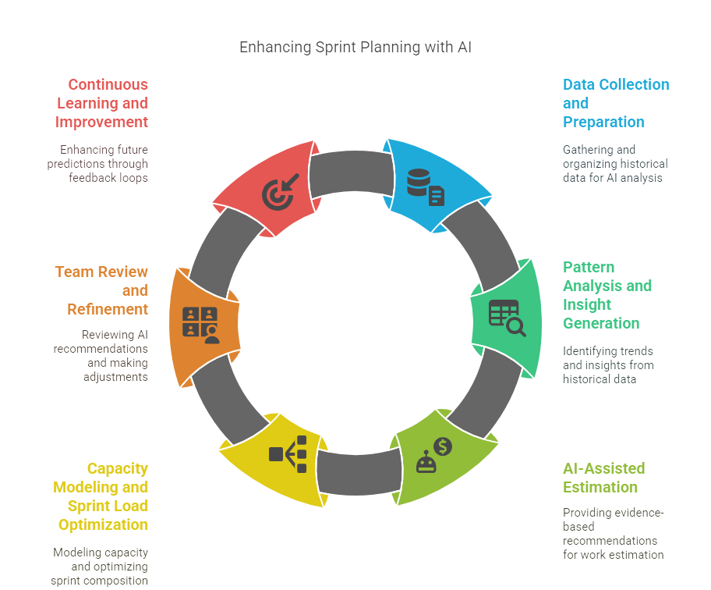

3. Acceptance Criteria (Given–When–Then)
Acceptance criteria are defined in detail for the user stories selected for Sprint 1 (see Section 5). Each criterion is written to be specific, measurable, and testable.
US1 As a warehouse manager, I want to track relief supply inventory levels in real time, so that I always know what resources are available.
Given a warehouse has relief items registered in the system
When an item's quantity changes due to inbound stock or dispatch
Then the dashboard reflects the updated quantity within 5 seconds and logs a timestamped entry
Story Points: 5 | Priority: High
US2 As a relief coordinator, I want to receive automatic low-stock alerts, so that I can reorder critical supplies before they run out.
Given an item's stock falls below its configured minimum threshold
When the inventory monitoring service runs its periodic check
Then an alert notification is sent to the relief coordinator and displayed on the dashboard within 1 minute
Story Points: 3 | Priority: High
US4 As a relief coordinator, I want the system to predict resource needs using disaster severity and population data, so that I can allocate supplies proactively.
Given current disaster severity score and affected-area population data are available
When the coordinator requests a demand forecast for a region
Then the AI model returns predicted quantities for food, medicine, and shelter items with a confidence score, within 10 seconds
Story Points: 8 | Priority: High
US6 As a logistics manager, I want the system to calculate optimal delivery routes accounting for road damage and traffic, so that relief supplies reach affected areas faster.
Given a delivery destination and current road/traffic condition data are available
When the logistics manager requests a route for a shipment
Then the system returns the fastest available route, excluding any roads flagged as damaged or blocked, and displays estimated arrival time
Story Points: 8 | Priority: High
US9 As an NGO coordinator, I want a shared dashboard visible to all participating agencies, so that we avoid duplicate efforts and resource conflicts.
Given multiple agencies are registered and operating in the same disaster zone
When any agency updates a resource allocation or task assignment
Then the change is reflected on all agencies' dashboards in real time, tagged with the agency and timestamp
Story Points: 5 | Priority: High
US12 As a shelter manager, I want to log and update shelter occupancy in real time, so that displaced people can be directed to shelters with available space.
Given a shelter has a registered maximum capacity
When the shelter manager updates the current occupant count
Then the system recalculates and displays remaining capacity immediately and marks the shelter as "full" if capacity reaches its maximum
Story Points: 3 | Priority: Medium
US16 As a disaster analyst, I want the system to assess disaster severity using satellite/GIS data and IoT sensor feeds, so that response efforts are prioritized correctly.
Given GIS imagery and IoT sensor readings (water level, structural, weather) are being received for a region
When the analyst triggers or the system auto-runs a severity assessment
Then a severity score and classification (e.g., Low/Medium/High/Critical) is generated per zone and displayed on the map within 15 seconds
Story Points: 8 | Priority: High

Acceptance Criteria Summary (Remaining Backlog Stories)
Story | Key Acceptance Criterion (Condensed)
US3 | Given a field update is submitted, when synced, then inventory reflects the change within 1 minute even in low-connectivity mode.
US5 | Given regional data exists, when a forecast is generated, then it is broken down and viewable per administrative region.
US7 | Given a route is active, when road conditions change, then navigation re-calculates and alerts the driver within 30 seconds.
US8 | Given a vehicle has a GPS tracker, when it is in transit, then its live position updates on the map every 15 seconds.
US10 | Given an agency sends an alert, when it is marked urgent, then all relevant agencies receive a push notification within 10 seconds.
US11 | Given a zone is unassigned, when an official assigns it to an agency, then the zone status updates and is locked from reassignment without approval.
US13 | Given shelters have available capacity, when a citizen searches nearby, then only shelters with space are shown, sorted by distance.
US14 | Given a reporting period ends, when a report is generated, then it includes resources distributed, delays, and agency performance, exportable as PDF.
US15 | Given distribution data exists, when the dashboard loads, then coverage gaps are visually highlighted by region.
US17 | Given severity scores exist per zone, when the heat map is opened, then zones are color-coded by severity and clickable for detail.

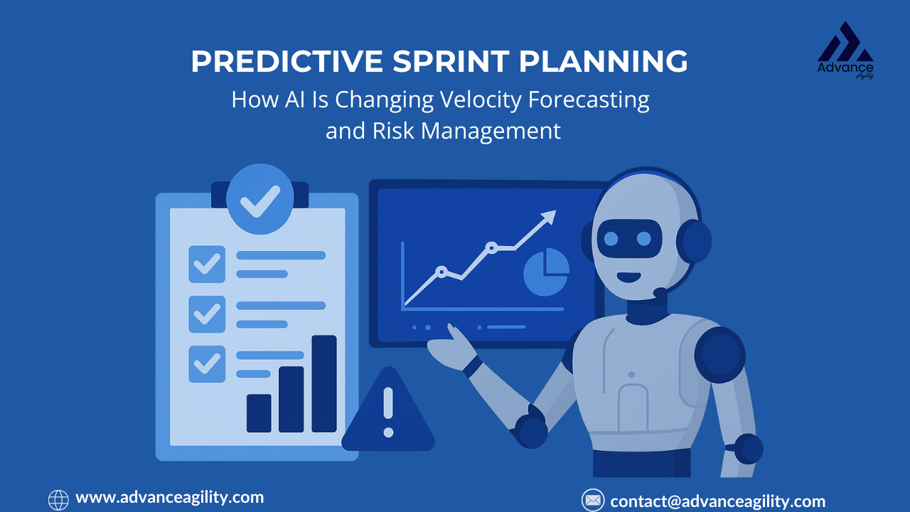

4. Product Backlog Prioritization
The backlog is prioritized using a combination of MoSCoW categorization and business value scoring (1–10), accounting for dependencies (e.g., demand prediction and routing depend on severity assessment and inventory data being available first).
# | User Story | MoSCoW | Business Value | Dependency
1 | US1 - Real-time inventory tracking | Must | 9 | None (foundational)
2 | US16 - Disaster severity assessment (GIS/IoT) | Must | 10 | None (foundational)
3 | US2 - Low-stock alerts | Must | 8 | Depends on US1
4 | US4 - AI demand prediction | Must | 9 | Depends on US16
5 | US9 - Shared multi-agency dashboard | Must | 9 | Depends on US1, US16
6 | US6 - Optimized delivery routing | Must | 8 | Depends on US16
7 | US12 - Shelter occupancy tracking | Should | 7 | None
8 | US17 - GIS severity heat map | Should | 7 | Depends on US16
9 | US10 - Real-time agency alerts | Should | 6 | Depends on US9
10 | US3 - Mobile inventory updates | Should | 6 | Depends on US1
11 | US8 - Live vehicle tracking | Should | 6 | Depends on US6
12 | US5 - Region-wise demand forecast | Could | 5 | Depends on US4
13 | US11 - Zone/task assignment | Could | 5 | Depends on US9
14 | US13 - Citizen shelter finder | Could | 5 | Depends on US12
15 | US7 - Real-time driver navigation | Could | 4 | Depends on US6
16 | US14 - Automated logistics reports | Won't (this sprint) | 4 | Depends on US1, US6, US9
17 | US15 - Analytics dashboard with gap analysis | Won't (this sprint) | 4 | Depends on US4, US14



5. Sprint Backlog Plan (Sprint 1)
Sprint 1 duration: 2 weeks. Team: 2 Backend Developers, 2 Frontend Developers, 1 AI/ML Engineer, 1 GIS Specialist, 1 QA Engineer, 1 Scrum Master, 1 Product Owner.
The seven highest-priority, least-dependent "Must Have" stories are selected for Sprint 1, since they form the foundational data layer (inventory + severity assessment) that later AI and coordination features depend on.

Selected Sprint 1 Stories and Task Breakdown
Story | Development Tasks
US1 - Real-time inventory tracking | Design inventory DB schema; build inventory CRUD API; build real-time sync (WebSocket); build inventory dashboard UI; write unit/integration tests.
US16 - Disaster severity assessment | Integrate GIS/satellite data feed; integrate IoT sensor ingestion pipeline; build severity scoring model; build severity API endpoint; validate model output with sample data.
US2 - Low-stock alerts | Define threshold configuration model; build alert-trigger service; integrate notification service (push/SMS/email); build alert UI banner; test alert timing.
US4 - AI demand prediction | Collect/prepare historical training data; train baseline prediction model; build prediction API; integrate severity + population inputs; build forecast display UI.
US9 - Shared multi-agency dashboard | Design multi-tenant dashboard architecture; build role-based access control; build shared resource/task view; implement real-time update sync; UAT with sample agency accounts.
US6 - Optimized delivery routing | Integrate mapping/routing engine (e.g., GIS-based routing API); build road-condition data layer; implement route optimization logic; build route display UI; test against blocked-road scenarios.
US12 - Shelter occupancy tracking | Design shelter/occupancy data model; build occupancy update API; build capacity calculation logic; build shelter status UI; test full/near-full state handling.



6. Story Point Estimation (Fibonacci / Planning Poker)
Estimation was performed using Planning Poker with the Fibonacci sequence (1, 2, 3, 5, 8, 13, 21), where the team independently estimates each story and discusses outliers until consensus is reached. Points reflect complexity, effort, and uncertainty — not strictly duration.
Story | Story Points | Justification
US1 - Real-time inventory tracking | 5 | Moderate complexity: real-time sync and dashboard UI, but a well-understood CRUD + WebSocket pattern.
US16 - Disaster severity assessment | 8 | High complexity: integrating multiple external data sources (GIS, IoT) plus a scoring model with real-world data uncertainty.
US2 - Low-stock alerts | 3 | Low-medium complexity: depends on existing inventory data; mainly threshold logic and notification integration.
US4 - AI demand prediction | 8 | High complexity: requires model training, feature engineering, and integration with severity data; accuracy validation adds uncertainty.
US9 - Shared multi-agency dashboard | 5 | Moderate-high complexity: role-based access and real-time multi-tenant sync across agencies.
US6 - Optimized delivery routing | 8 | High complexity: routing optimization algorithm plus live road-condition integration and edge-case handling (blocked roads).
US12 - Shelter occupancy tracking | 3 | Low-medium complexity: standard CRUD with capacity calculation logic; limited external dependencies.
Total Sprint 1 Capacity Committed: 40 story points.

7. Sprint Goal and Expected Deliverables

7.1 Sprint Goal
"Establish the platform's foundational data layer — real-time resource inventory and AI-driven disaster severity assessment — and deliver the first working versions of demand prediction, optimized routing, shelter occupancy tracking, and a shared multi-agency dashboard, enabling coordinated visibility for relief operations."

7.2 Expected Sprint Deliverables
- A working real-time inventory tracking module with a live dashboard and low-stock alerting.
- A disaster severity assessment engine integrating GIS and IoT data, producing zone-level severity scores.
- A baseline AI demand prediction model generating resource forecasts from severity and population data.
- An optimized delivery routing feature accounting for road damage and live traffic conditions.
- A shared, role-based multi-agency dashboard showing resources, severity, and tasks in real time.
- A shelter occupancy tracking module showing live capacity per shelter.
- A demo-ready increment reviewed in the Sprint Review, with a retrospective identifying improvements for Sprint 2 (which will add reporting, analytics, citizen-facing shelter finder, and driver navigation).

7.3 Definition of Done
- Code is peer-reviewed, merged, and deployed to the staging environment.
- Unit and integration tests pass with acceptance criteria fully met.
- Feature is demonstrated to the Product Owner and accepted in the Sprint Review.
- Documentation (API/user) is updated.

